Created Instance:
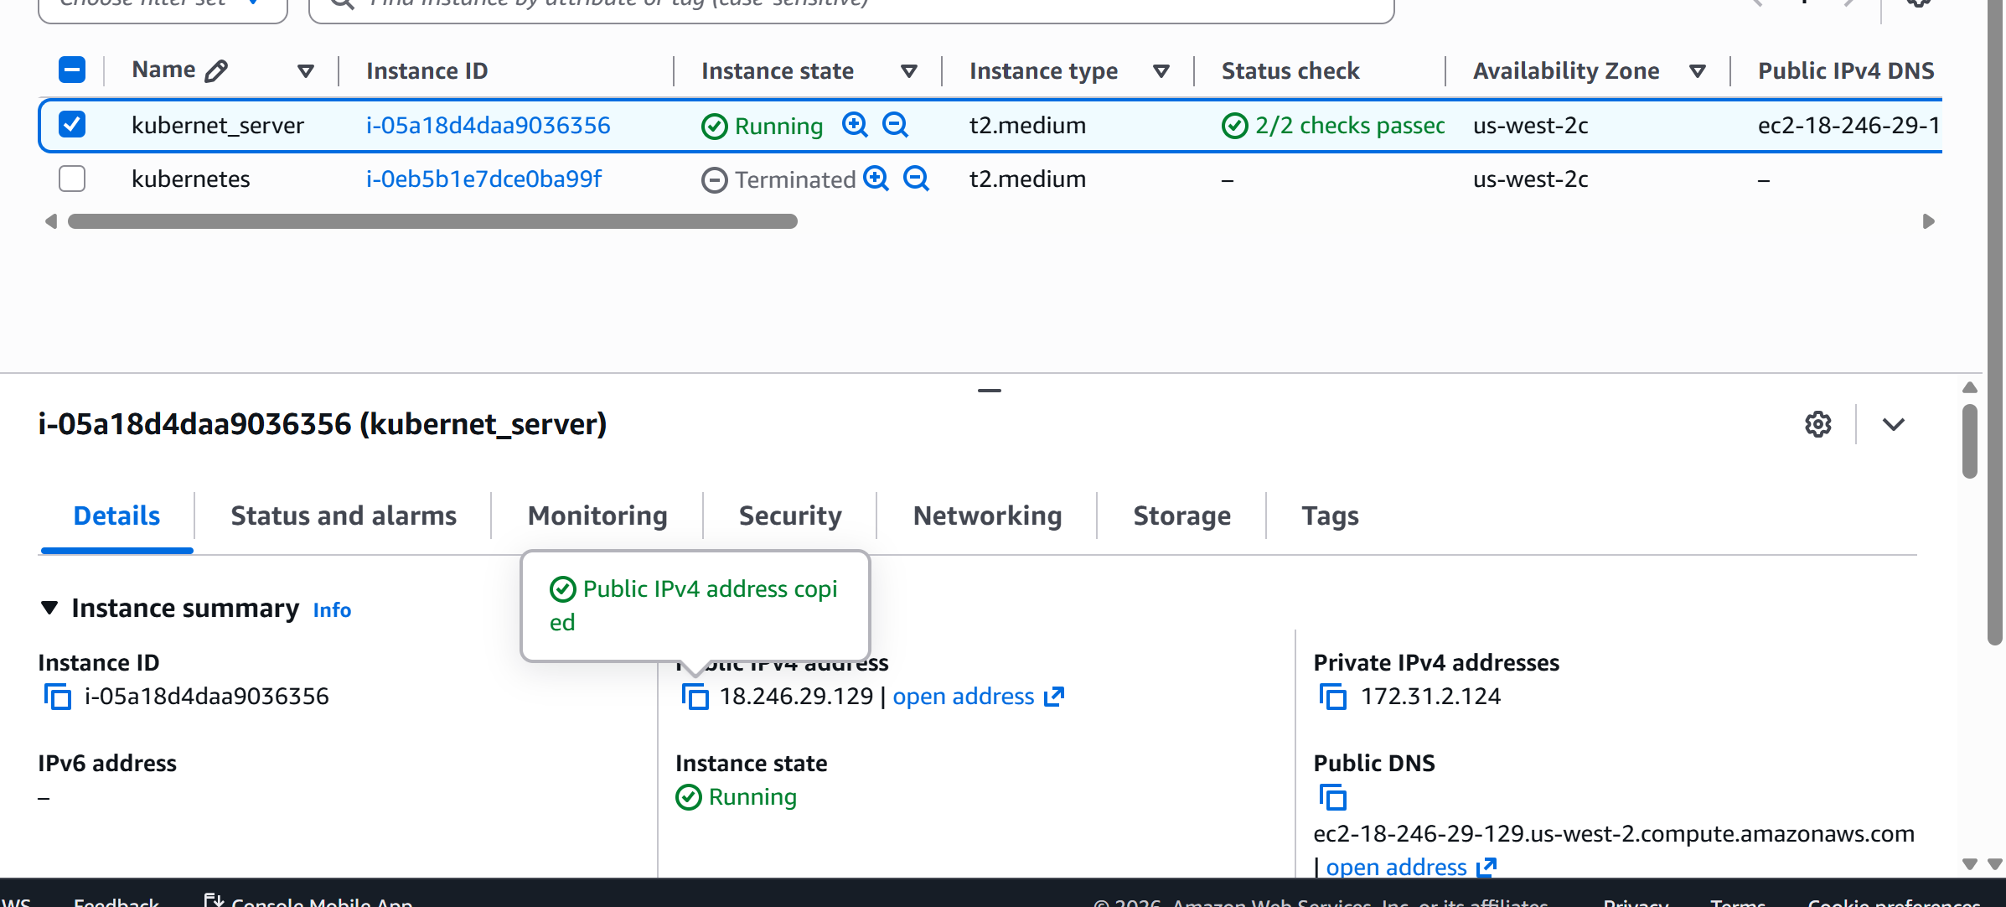
Corrected Security Group:
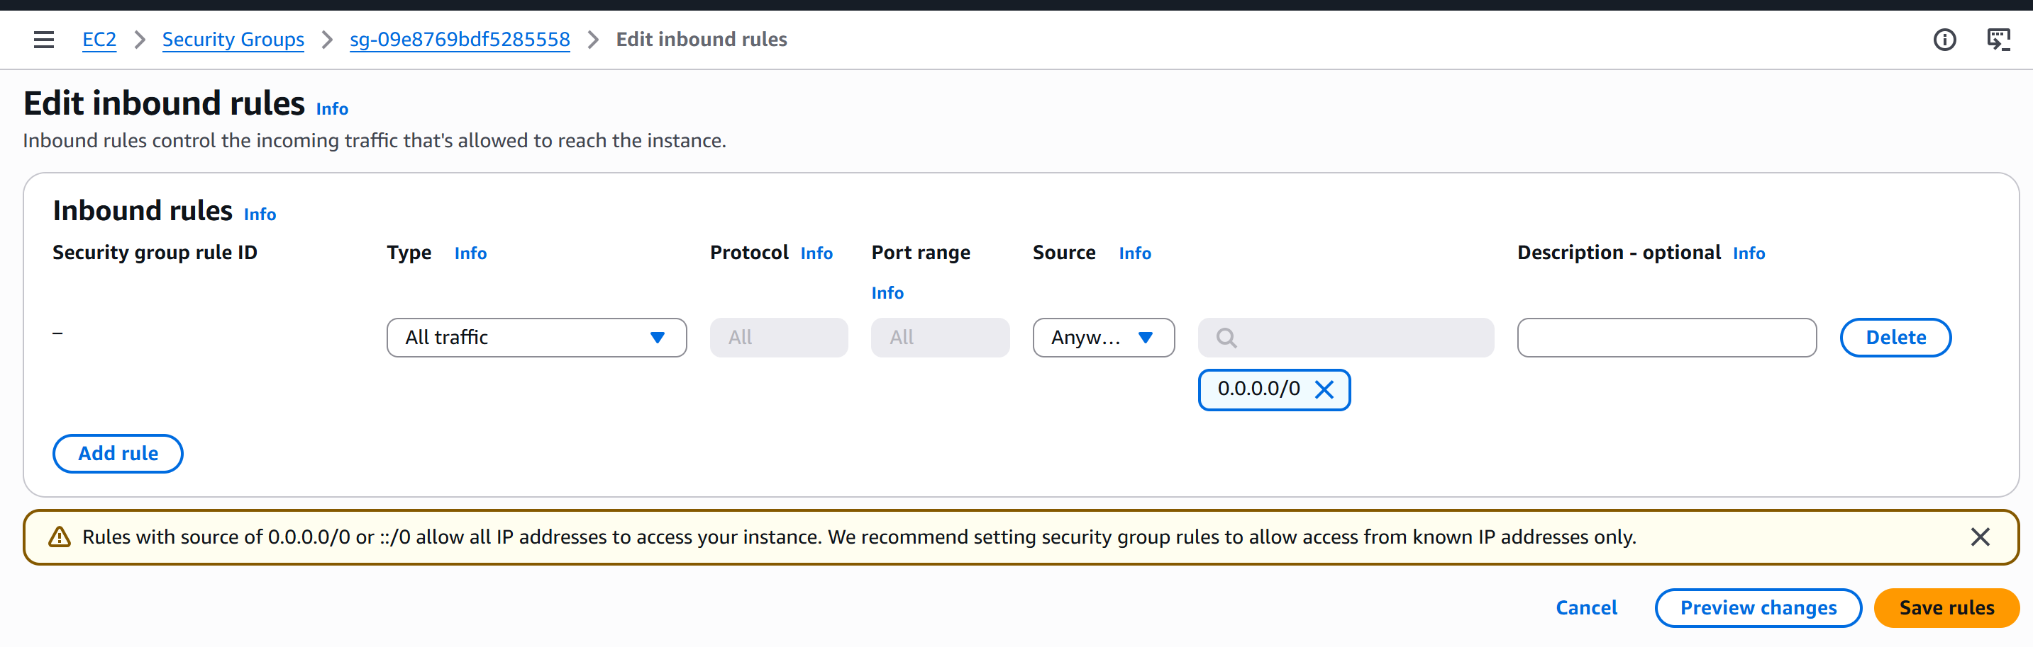
Connected to Insatnce:

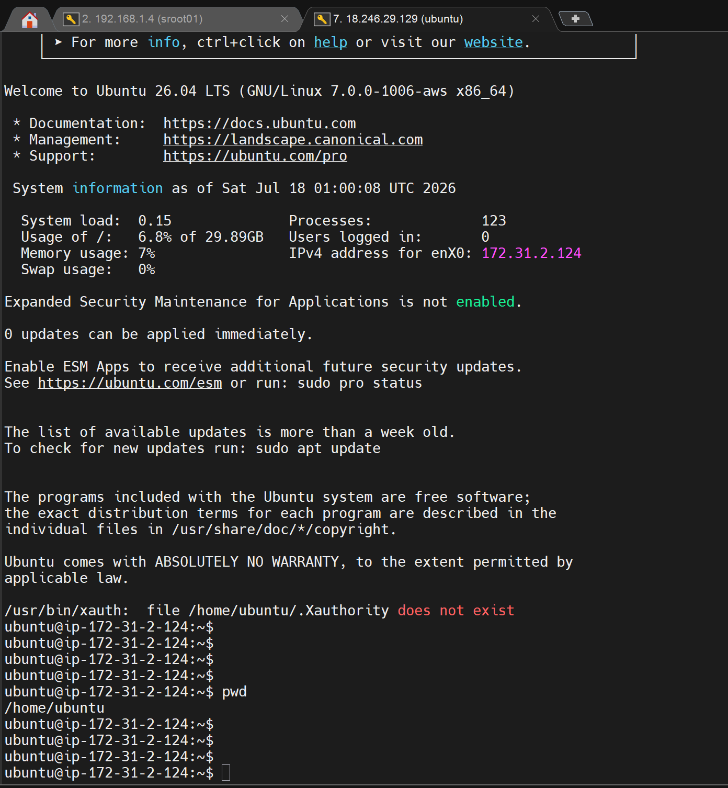

Creating POD:

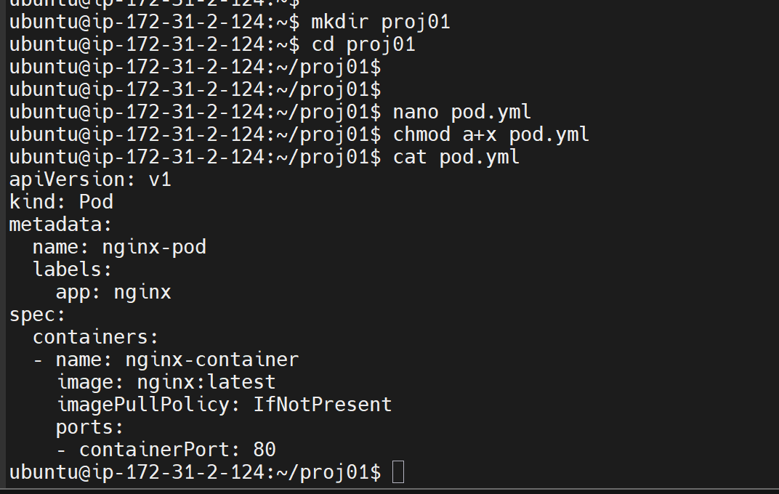

Installing K3S

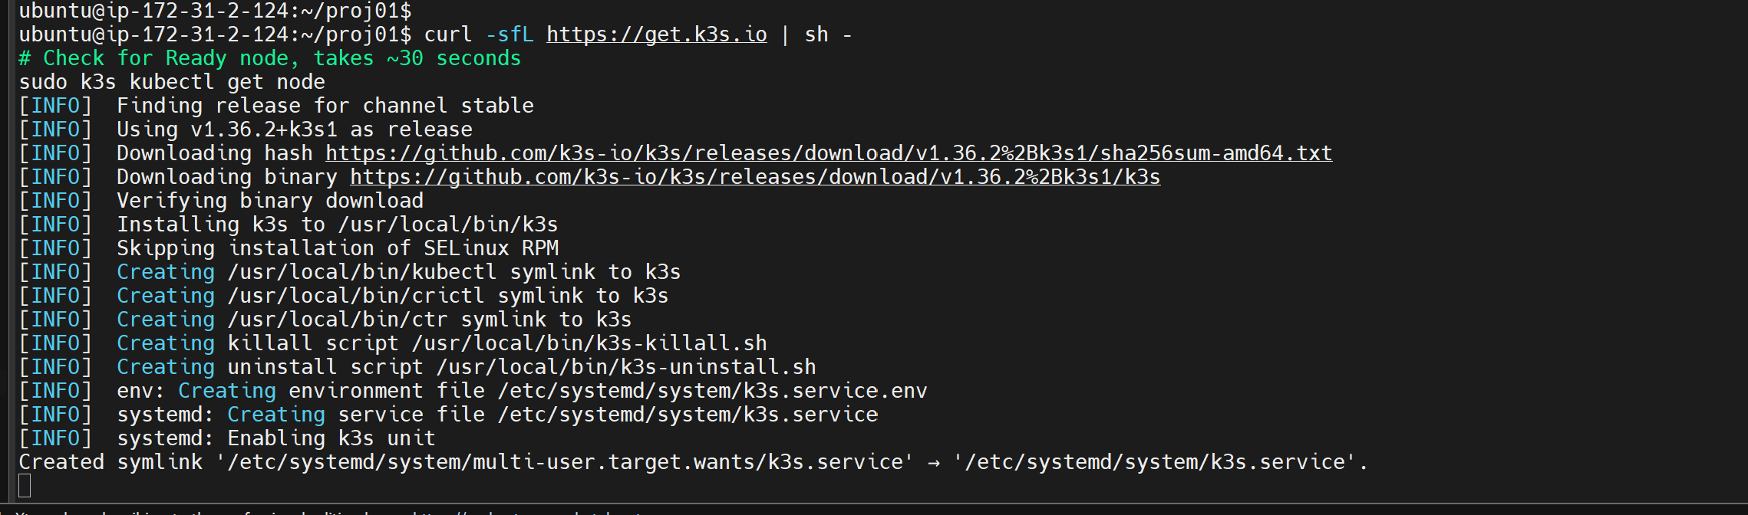

PODs running:

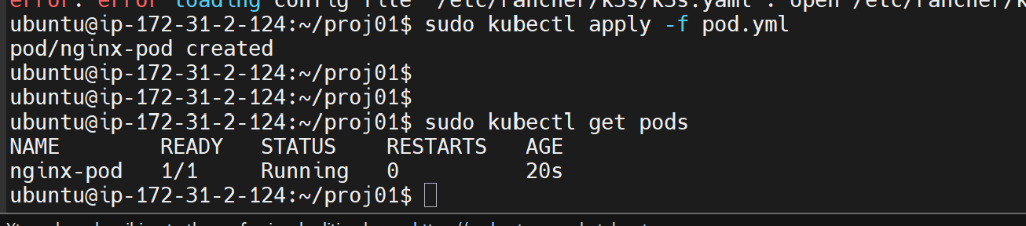

Created nodeport to access outside:

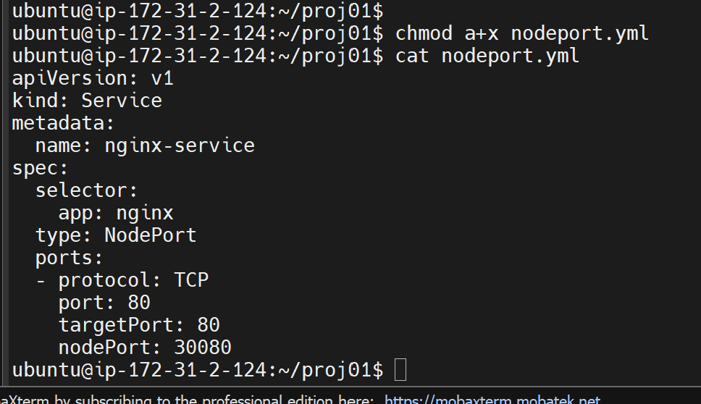
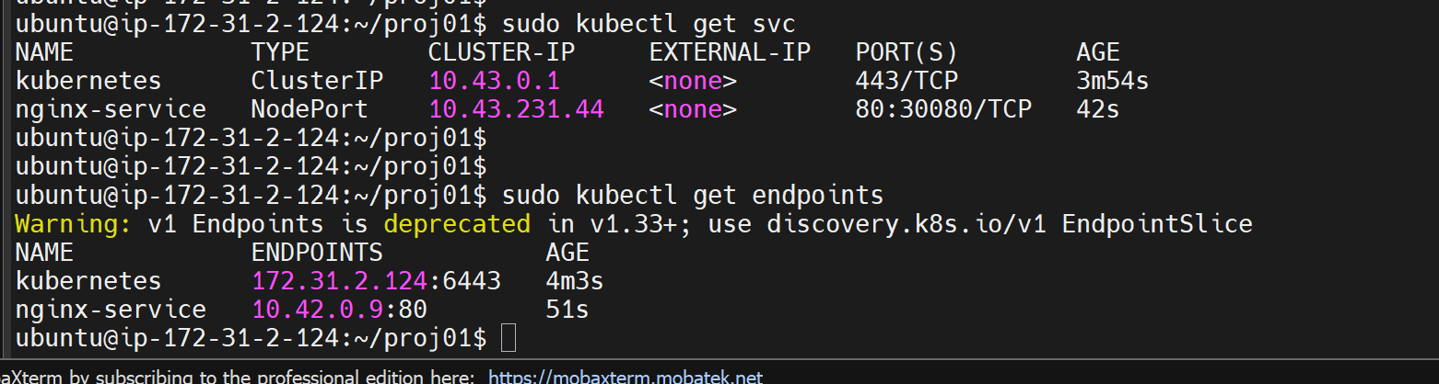

Accessible outside using public IP address:30080 nodeport

